**Let’s move to the Index page:**

**Introduction:**

Our today’s task is to provide an overview of the project synopsis of the project, Real-Time Stock Market Web Application. And its description as follows: Our project is full stack Web Application of Stock Market. It allows users (means investors) to track real-time stock market data in a comprehensible format. It provides up-to-date information on stock prices, volume, market trends, and other relevant data which are retrieve from APIs. The application prioritizes user security and privacy, incorporating features like user authentication and robust security measures to safeguard sensitive information.

Now our task instruction is to understand the project synopsis and deliver a professional presentation in today’s meeting.

Let’s discuss about the key features of project are:

* ***Real-time stock market data***: The web application pulls real-time stock market data from APIs and displays stock prices, volume, market trends, and other information.
* ***User Authentication and Security:*** The web application has features such as user authentication and security to ensure that user data is protected.
* ***Easy-to-Understand Format:*** The web application displays stock market data in an easy-to-understand format, making it easier for investors to track their investments.
* ***Responsive Design:*** The web application is designed to be responsive, making it easy to use on different devices.

So first of all, there should be question rises in mind, **why do we need this website?**

1. By utilizing the Alpha Vantage APIs, users get the most up-to-date and accurate information on stock prices, volume, market trends, and more. This level of precision enables investors to make informed decisions and track their investments effectively.
2. Secondly, the web application ensures that the data displayed is updated on every minute, offering real-time insights into the dynamic stock market. This feature is crucial for investors who require immediate access to the latest market data to stay ahead of market fluctuations and capitalize on investment opportunities promptly. ~~By continuously updating the information, the application keeps users informed about the most recent developments, enhancing their ability to make timely investment decisions.~~
3. Additionally, the Stock Market Data Web Application promotes company-investor interaction. It serves as a platform that facilitates communication and engagement between companies and investors. With the wealth of information available, investors can gain a deeper understanding of companies, their financial performance, and market trends. This promotes transparency and empowers investors to make informed choices while fostering a stronger connection between companies and their stakeholders.

~~Overall, the Stock Market Data Web Application distinguishes itself by providing precise information, real-time data updates, and fostering company-investor interaction. These features combine to offer investors a powerful tool for tracking investments, making informed decisions, and engaging with the stock market in a meaningful way.~~

Our next slide is based on the tools and techniques used to make this project:

* 1. For Front -End, we used HTML, CSS, JavaScript, & React.js
  2. For Back-End; we use Node.js, and express.js libraries & storing the data in MongoDB database.
  3. For APIs; we used most renowned and trustful API service by Alpha Vantage API

Now we discuss all of them a little deeper;

**In Front-end:**

1. HTML used for creating the structure of web design, page layouts, tags and attributes.
2. While CSS is used for designing, styling, and decorating the web pages & helps to achieve through responsive web design techniques.
3. 3rd point is JavaScript; It allows users to interact with web pages. It allows us to add dynamic behaviour to the webpage and add special effects to the webpage. To add interactive elements that engage users. Without JavaScript, 90% of Internet webpages would be static.
4. Last tool for Front-end is React.js; React lets us build rich user-interfaces easily. It is an open-source JavaScript framework. Used for building interactive user interfaces and web applications quickly and efficiently with significantly less code than you would with JavaScript.

**Forwarding to the Back-End:**

1. Node.js; Superpower of Node.js is the fast processing of real-time requests. Node.js is only good for small applications with the same light requests. But Node.js makes a good backend for real-time communication support kinds of applications that allow two-way communication between clients and servers. Its single-threaded functionality makes it best suited for real-time communication.
2. 2nd point is Express.js; It is the most popular backend framework for Node.js, and it is an extensive part of the JavaScript ecosystem. It allows to handle large amounts of traffic with ease. Express.JS is highly flexible and can be used to build a wide range of web applications, from simple websites to complex APIs.
3. 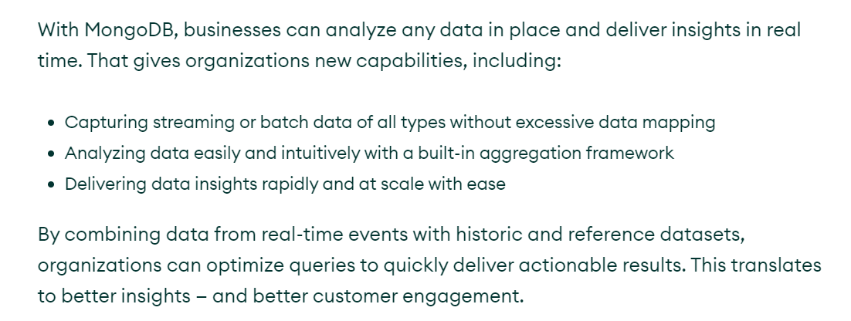Now all data has to be stored somewhere which is too much flexible for business idea. So, we stick to a database manager called MongoDB database manager. It facilitates storing nested data that can be used to store complex data patterns in the same documents. This makes it easier to fetch data and work on it.

* **Last tool required for real time web application is APIs;** APIs are used to integrate new applications with existing software systems (which is our website here). This increases development speed because each functionality doesn't have to be written from scratch. APIs are used to integrate new applications with existing software systems. This increases development speed because each functionality doesn't have to be written from scratch.
  + Alpha Vantage APIs Alpha Vantage provides enterprise-grade financial market data through a set of powerful and developer-friendly data APIs.
  + News Api mainly used for searching the articles published over Thousands of news sources and blogs.
* Path Flow of Working Project:
  + At first, we interact with Home Page / Authentication Page, then fill your credentials if not then one should go for Sign Up and create his/her account after verification mail sent to his/her Gmail-account. Then he/she would be logged in.
  + Then investor go for search box and type company name, press search button, API server receives the request and processes it. The API server fetches the requested data from its database or real-time data sources.
  + Once the API server processes the request and retrieves the requested data, it formulates a response.
  + The server-side function receives the API response from the Alpha Vantage APIs & formulates a response to send back to the front-end of the web application.
  + And Collected Data Visualization occurs in various patterns on front-end.
* Challenges:
* Conclusions: In conclusion, the Stock Market Data Web Application offers investors a reliable and user-friendly platform to access real-time stock market data. With its precise information, continuous data updates, and emphasis on company-investor interaction, the website provides a valuable resource for investors to make informed decisions, track their investments effectively, and stay connected with the dynamic world of the stock market.